# Investment banking project

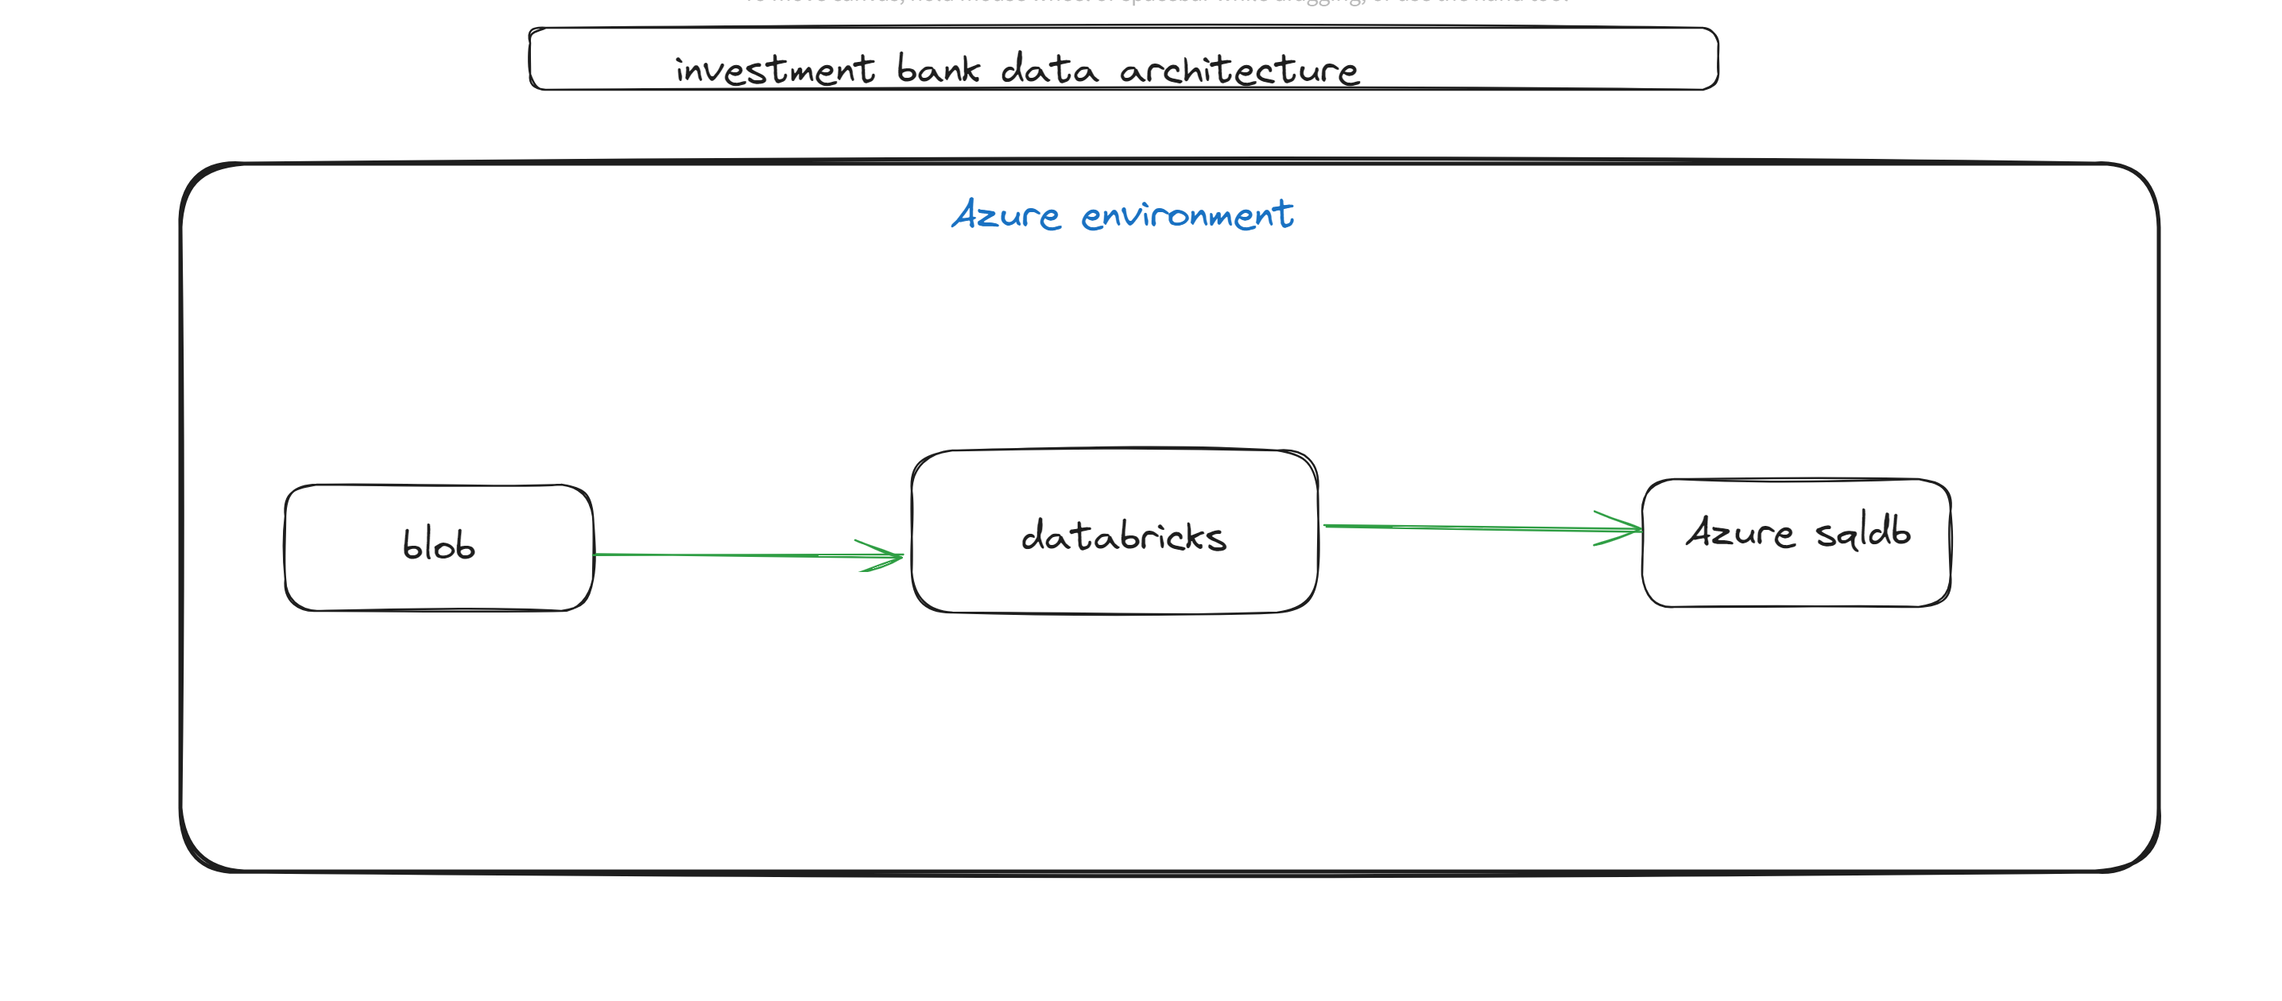

Notebook: investement_banking_pyspark_dbk_pip.ipynb

Final table in sql

select * from FROM [dbo].[investment_bank_clen_tbl]

